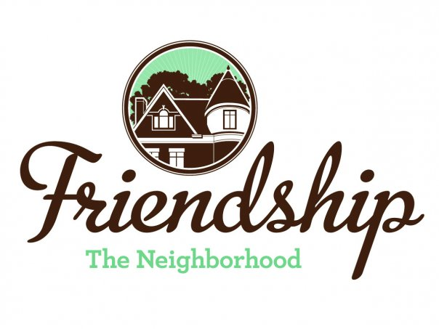 FRIENDSHIP COMMUNITY GROUP (FCG)

Housing and Business Borders Committee (HBBC)
Meeting Summary

Meeting Date/Time: Tuesday, August 4, 2020
6:30 pm

Location: Zoom Video Conference

Committee Members:  Chair: Vince Manetti  Board Member Representatives: Jayne Bower, Sara DeLucia, Tom Hritz, Danielle Novick, Tom Youngs  Community Representatives: John Axtell, Jennifer Haven | Attendees:  Vince Manetti  Sara DeLucia, Tom Hritz, Tom Youngs  John Axtell, Jennifer Haven,  Residents: Barbara Adams, Emily George, Lewis Kwett, Brian Sullivan
AGENDA ITEM | SUMMARY
Neighborhood Development Updates  - Penn Plaza - Enright Park  - Update on construction  - Update on attorney’s invoices  - Key Bank, Penn and Negley  - Baumhaus Phase II update  - Graffiti  - 5226 Penn Ave  - Update regarding discussion with owner (Jennifer)  - Recent trash issue  - Shur-Sav (Bloomfield)  - Penn Avenue Phase II  - Update on HBBC letter  - Howard Hanna Shadyside Office, 5501 Baum Boulevard | - -  - Construction continues  - One Housing Committee meeting has been held  - The TRID is now limited to ½ mile from East Liberty Transit Station  - No update from attorneys on invoices, John will request a “statement of account” from the attorneys  - Work continues with an estimated completion date of the first week of October, 2020  - There was discussion of recent, somewhat artistic, graffiti in the rear of Baumhaus I  - Brian offered to contact the owners to see how they planned to address the graffiti  - -  - Owner is still reviewing proposed community agreement  - Owner has purchased adjacent “green building”  - Trash was removed (may not have belonged to building owner)  - No update  - -  - No update, letter under review to support Bloomfield Development Corporation’s (BDC) response to City as well as to state HBBC’s concerns  - -  - John summarized draft and non-public architect’s presentation  - Jennifer attended a Zoom meeting with building owners and BDC  - Jennifer will send a letter to building owners / architect / City regarding required City processes to comply with Registered Community Organization regulations
Neighborhood Environment Updates  - Baum-Center Initiative (BCI) participation  - Regular update  - Residential Permit Parking (Tom)  - “Rightsizing” the trash cans at various buildings  - DPW graffiti policy clarification (Tom)  - Update to FCG website  - Children’s Home HVAC noises  - Baum Grove street art project grant – Bloomberg Philanthropic Arts Initiative (Jennifer and Sara)  - New tax abatement programs presentation  - Jennifer - November  - Continuation of discussion of “house flippers” in Friendship  - Jennifer and Sara for information on regarding mortgage payments on FCG website  - John and Jennifer developing a presentation regarding actions homeowners may consider when approached by house flippers.  - Coral Street Neighborway  - Develop resolution for FCG Board support of BDC / Bloomfield Livable Streets letter to City  - Hertz location at three-way intersection of Baum, Negley and Roup.  - Reuse of space as a result of the Hertz bankruptcy.  - West Penn Hospital Institutional Master Plan (Planning Commission meeting on July 28, 2020)  - Status of conversation with Christina Howell at BDC  - Rite Aid, Baum Boulevard - Concerns among residents and on NextDoor about loitering after hours in the rear of the building.  - PWSA work on Baum Boulevard | - -  - Barbara Adams, FCG representative at BCI, discussed –  - that BCI is reviewing steps to become a registered community organization,  - Luna parking garage retaining wall at the UPMC cancer center on Baum Boulevard will take several months to repair, and  - John O’Dell building on Baum Boulevard is condemned but he does not have any current plans for the location  - No update  - No update  - No update  - No update  - Project will be jointly led by FCG and the City Department of Mobility and Infrastructure (DOMI)  - Timing of implementation has been shifted to spring of 2021  - There will be an upcoming near neighbor communication  - On schedule  - -  - At the conclusion of the previous HBBC meeting, Jennifer had provided information to be posted to the FCG website  - John and Jennifer are continuing to prepare a presentation  - -  - Resolved: The Friendship Community Group Board of Directors hereby supports the letter dated May 19, 2020 to DOMI Director, Karina Ricks, written by Bloomfield Livable Streets and BDC as posted at https://bloomfieldlivablestreets.org/our-campaigns/comrie-way-coral-street-neighborway/  - There was also another recent neighborhood meeting regarding the Neighborway and plans are progressing.  - Discussion was postponed to a future meeting  - The Institutional Master Plan was approved by the Planning Commission  - No update on conversation  - Barbara Adams reported that information regarding City resources for the homeless was presented to individual loitering at the location  - PWSA moved work to daytime hours
2020 Goals Updates  - Update HBBC mission statement, vision and website.  - Meeting presenters have changed based upon COVID-19 stay-at-home orders. Presentations below are tentative –  - Permits, Licenses and Inspections (9/1/20)  - Pittsburgh Glass Center (regarding nearby proposed renovations) (11/3/20?)  - Environmental Services Enforcement (FCG Quarterly Community Meeting?)  - Graffiti (FCG Quarterly Community Meeting?) | - No update  - -  - Scheduled  - Under review, facility may still be closed  - Scheduled for August 20, 2020  - No update
Long Term Goals
- HBBC recommendation that FCG should consider applying for a grant to develop a new strategic plan / community plan
  - Incorporate consideration of expansion of RCO boundaries
  - Incorporate possible development of “Penn Avenue overlay”
  - Include possibility of neighborhood zoning changes?

Not Actively Tracked Projects

- 5222 Penn Ave renovations update
- North Negley Residences – B’nai Israel
- Montana Building on Penn Avenue – renovations
- Two Frays Brewing on Penn Avenue - development
- Aldi renovations (Baum Blvd)

New | - Hertz vehicles parked throughout neighborhood and at Baum Grove  - Hertz agreed at City Zoning Board of Adjustment several years ago to not use the neighborhood for parking  - Tom agreed to write letter to Hertz voicing neighborhood’s concerns  - Barbara stated that she had sent an email message to Wendy Urbanic at Pittsburgh 311 regarding a large hole on Roup Avenue
Next Meeting  September 1, 2020, Location TBD | Meeting adjourned at 8:45 pm

