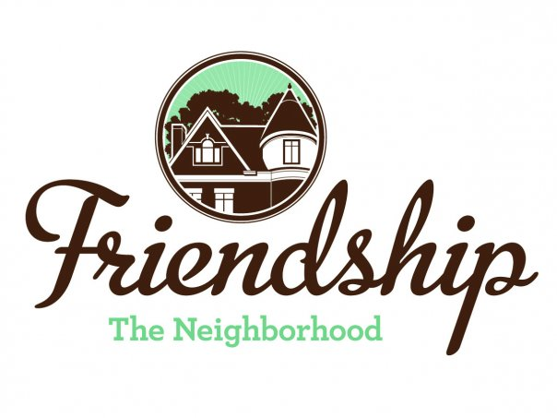 FRIENDSHIP COMMUNITY GROUP

Housing and Business Borders Committee
Summary

Meeting Date/Time: Tuesday, July 7, 2020
6:30 pm

Location: “ZOOM” Video Conference

Committee Members:  Chair: Vince Manetti  Board Member Representatives: Jayne Bower, Sara DeLucia, Tom Hritz, Danielle Novick, Tom Youngs  Community Representatives: John Axtell, Jennifer Haven | Attendees:  Vince Manetti  Sara DeLucia, Tom Youngs  John Axtell, Jennifer Haven  Residents: Barbara Adams, Brian Sullivan  Guest: Wendy Urbanic, 311 Manager, City of Pittsburgh, 311 Response Center
AGENDA ITEM | SUMMARY
Guest Presenter –  Wendy Urbanic, 311 Manager  City of Pittsburgh  311 Response Center | Ms. Urbanic presented over Zoom to the Committee.  - 311 Response Center reports in the City to the Department of Innovation and Performance  - Ms. Urbanic gave a presentation regarding how 311 operates  - She then was able to respond to questions –  - Car and home noise alarms should be reported to 911  - Commercial trash haulers picking up trash outside of normal working hours should be reported to 311 along with the name of the company  - Trash at privately-owned buildings can be reported to 311 who will submit to the City’s departments of Permits, Licensing and Inspections and Environmental Services  - Ms. Urbanic also said that individuals may send specific addresses to her through email
Neighborhood Development Updates  - Penn Plaza - Enright Park  - Update on actions in City Council  - Update on construction  - Update on attorney’s invoices  - Key Bank, Penn and Negley  - Baumhaus Phase II update  - 5226 Penn Ave  - Update regarding discussion with owner (Jennifer)  - Shur-Sav (Bloomfield)  - Resolution presented to Bloomfield Development Corporation (Jennifer)  - Penn Avenue Phase II  - FCG Board resolution passed at 6/10/20 Meeting, FCG –  - 1) supports the Bloomfield Development Corporation’s and Bloomfield Livable Streets’ letter dated May 19, 2020 to the City of Pittsburgh Department of Mobility and Infrastructure Director regarding Phase II Penn Avenue Reconstruction as can be found at -https://bloomfieldlivablestreets.org/our-campaigns/penn-avenue-reconstruction-phase-ii/ and  - 2) requests that BDC keep FCG updated regarding responses to the letter.  - Additional information - https://apps.pittsburghpa.gov/redtail/images/8591_Penn_Ave_Phase_II_Presentation_02_06_20.pdf | - -  - City Council did not approve of the TRID expansion from ½ mile to ¾ mile  - Construction continues although no work on park  - No update on invoices  - Committee submits a resolution to FCG Board to change the FCG representative on the Penn Plaza housing committee from Martha Terry to Enright Park area resident, Jason Roth  - Construction continues. Goal of October 2, 2020 completion.  - Neighborhood agreement signed by all three parties. Developers soon to present to City Planning Commission  - No update  - -  - Jennifer discussed the resolution that was passed at a recent FCG Board meeting with Christina Howell at BDC  - New site owners, Echo Realty, announced that Shur-Sav will close and re-open as a Community Market for some undetermined interim period of time  - Vince stated he will sign and send the FCG letter to DOMI in support of BDC’s letter to City
Neighborhood Environment Updates  - Baum-Center Initiative (BCI) participation  - Regular update  - Residential Permit Parking (Tom)  - “Rightsizing” the trash cans at various buildings  - Inviting Donald Matthews from the City to a future HBBC meeting (Brian Sullivan and Vince)  - DPW graffiti policy clarification (Tom)  - Update to FCG website  - Children’s Home HVAC noises  - FCG Board resolution passed at 6/10/20 Meeting –  - The FCG Board of Directors grants the Housing and Business Borders Committee continuing authority to pursue resolution of noise issues at the Children’s Home primarily through interaction with the City.  - Baum Grove street art project grant – Bloomberg Philanthropic Arts Initiative (Jennifer)  - New tax abatement programs  - Jennifer - November  - Continuation of discussion of “house flippers” in Friendship  - Jennifer and Sara for information on regarding mortgage payments on FCG website  - John and Jennifer developing a presentation regarding actions homeowners may consider when approached by house flippers.  - Coral Street Neighborway  - Further review of BDC letter.  - Hertz location at three-way intersection of Baum, Negley and Roup.  - Reuse of space as a result of the Hertz bankruptcy.  - West Penn Hospital Institutional Master Plan (Planning Commission meeting on July 28, 2020) | - FCG representative to BCI, Barbara Adams, stated that BCI’s meeting minutes accurately summarize the recent meeting  - Tom reported that he had been in contact with Elaina Zaitsoff from the Coalition of Oakland Residents and that there has not been any update from the City about changes to the Residential Permit Parking program  - No update  - No update  - -  - FCG’s representative on this issue, Mike Dolan, continues to pursue  - City states that it found a company to analyze the noise and to produce a report, although no date has been set  - Jennifer reported that the grant had been received. There are many steps ahead –  - FCG Board to review and accept grant at meeting on July 8, 2020  - Bloomberg Philanthropies has very specific neighborhood communication requirements  - There will be a very engaged process on design with near neighbors  - In planning process  - No update. Will have more info next month.  - City recently presented to neighborhood. Stop signs will be replaced in several locations by yield signs. Bump-outs will also be installed. Maps of neighborway were recently updated. Committee will submit a resolution to FCG Board to support BDC letter.  - No update.  - Vince to contact Christina Howell at BDC for meeting.
2020 Goals Updates  - Update HBBC mission statement, vision and website.  - Meeting presenters have changed based upon COVID-19 stay-at-home orders. Presentations below are tentative –  - 311 (7/7/20)  - Permits, Licenses and Inspections (9/1/20)  - Pittsburgh Glass Center (regarding nearby proposed renovations) (11/3/20?)  - Environmental Services Enforcement (FCG Quarterly Community Meeting?)  - Graffiti (FCG Quarterly Community Meeting?) | - No update. Address at next meeting.  - -  - Complete  - Scheduled  - Under review  - Under review  - Under review
Long Term Goals  - HBBC recommendation that FCG should consider applying for a grant to develop a new strategic plan / community plan  - Incorporate consideration of expansion of RCO boundaries  - Incorporate possible development of “Penn Avenue overlay”  - Include possibility of neighborhood zoning changes? | - With FCG Board
Not Actively Tracked Projects  - 5222 Penn Ave renovations update  - North Negley Residences – B’nai Israel  - Montana Building on Penn Avenue – renovations  - Two Frays Brewing on Penn Avenue - development  - Aldi renovations (Baum Blvd) | No updates
New | - Rite Aid, Baum Boulevard - Concerns among residents and on NextDoor about loitering after hours in the rear of the building.  - Discussion of small motorcycle “club” in neighborhood on alley between Evaline and Pacific
Next Meeting  August 4, 2020, Location TBD | Adjourned at 8:45

