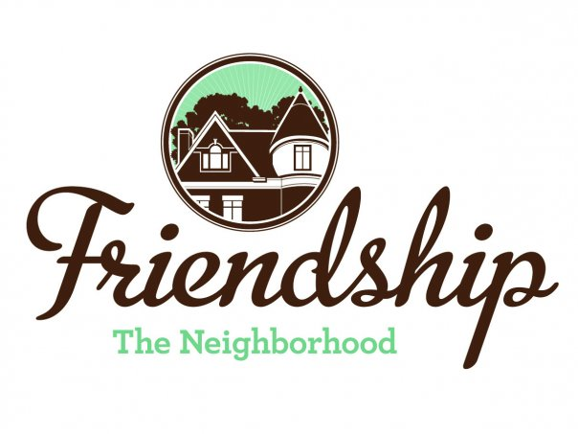 FRIENDSHIP COMMUNITY GROUP (FCG)

Housing and Business Borders Committee (HBBC)
Monthly Meeting Summary

Meeting Date/Time: Tuesday, January 7, 2020
6:30 pm
Location: Pittsburgh Glass Center
5472 Penn Avenue
Pittsburgh

Committee Members:  Chair: Vince Manetti  Board Member Representatives: Evan Stein, Tom Youngs  Community Representatives: John Axtell, Jennifer Haven | Attendees:  Vince Manetti  Tom Youngs  John Axtell, Jennifer Haven  Others in attendance –  Friendship residents - Barbara Adams, Brian Sullivan, Renée Zaffino
AGENDA ITEM | SUMMARY
Sally Stadelman, Government and Community Affairs, Department of Permits, Licenses, and Inspections  - How to confirm legal occupancy?  - How to work most efficiently to bring a concerted effort to hold real estate companies accountable?  - Discuss concerns with problem landlords  - What department handles trash issues – PLI or DPW?  - How to address illegally subdivided buildings  - Do inspectors respond to speculators hoping to obtain buildings at reduced prices? | Ms. Stadelman canceled earlier in the week as she took a new position in the City of Pittsburgh. HBBC will look to invite Ms. Stadelman’s replacement at some point in 2020.  Attendees discussed a few of these items –  - Friendship residents are reminded to contact the City’s 311 Response Center with concerns about ongoing suspicious activities at houses  - There was a discussion about the City laws regarding trashcan pickup  - Jennifer Haven suggested that Donald Matthews from the City will assist with a process of “rightsizing” the trash cans at various buildings  - Brian Sullivan and Vince Manetti will coordinate to invite Mr. Matthews to a future HBBC meeting.
Neighborhood Development Updates  - Penn Plaza-Enright Park (Jennifer and John)  - Liberty Ave and Baum retail development  - Key Bank, Penn and Negley  - Contact name and number?  - Baumhaus Phase II Update  - 5226 Penn Ave | - John Axtell reported that the contractor has mobilized and trees have been taken down. FCG and HBBC will be looking for good communication with the JJ Gumberg Co. throughout construction. The required housing committee has been formed. Friendship resident and FCG President, Martha Terry, has agreed to participate in this committee.  - Neighborhood calls to 311 have apparently made a difference in that Do Not Enter signs were installed on S. Pacific near Liberty. There were also white lines painted on Liberty near the intersection with S. Pacific to denote a “no parking” area. HBBC will continue to monitor this retail development especially as it involves smells from the restaurants.  - Work is progressing.  - The point of contact is the general contractor's job superintendent, Doug Rowland, of OakHill Building Co., Inc., based in Buffalo. He can be reached via e-mail at drowland@rpoakhill.com.  - John asked Renee Zaffino for a list of concerns. John will 1) combine that list with the items from the meeting summary from the HBBC meeting with Mike Gornick at Baumhaus on November 21, 2019 and 2) submit that combined list to HBBC for review prior to presenting to Mr. Gornick. This combined list of concerns must be presented prior to the owners of Baumhaus appearing at the City of Pittsburgh Zoning Board of Adjustment (ZBA) for various zoning requests. (No meeting date is set.)  - Owner presented to the ZBA on December 5, 2019. Decisions from that meeting have not yet been made public. The owner has not signed the agreement presented by FCG.
Miscellaneous Updates  - DPW graffiti policy clarification (Tom Y)  - Children’s Home HVAC noises  - City meeting regarding Baum Grove street art project (Jennifer) | - Tom Youngs has sent numerous email messages to Bll Crean at the City but has not received a response.  - HBBC has not heard much on this issue but several HBBC members are confident that Friendship resident, Mike Dolan, is following this issue closely.  - Jennifer Haven reported that a grant was submitted by the City. The City will be informed by April 2020 whether the grant is received. If so, the work will need to be completed by August 2020 and will need to be thoroughly publicized throughout the neighborhood. Vince will present information to the FCG Board.
Other Items  - To consider – should FCG boundaries be extended to include residents on Baum and Center near Baumhaus?  - To consider – should Friendship be rezoned? | - Tabled for discussion in 2020. Also consider areas near Enright Park.  - Tabled for discussion in 2020.
New Items  - 2020 goals and objectives?  - 2020 invited presenters? | - Possible items –  - FCG should consider applying for a grant to develop a new strategic plan / community plan  - Develop a “Penn Ave overlay” to possibly include FCG, Bloomfield- Garfield Corp and Bloomfield Development Corp.  - Consider amending Registered Community Organization boundaries  - Possible presenters –  - Environmental Services Enforcement  - Permits, Licenses and Inspections  - Pittsburgh Glass Center (regarding nearby proposed renovations)  Meeting adjourned 8:28 p.m.
Next Meeting

February 4, 2020, Pittsburgh Glass Center

