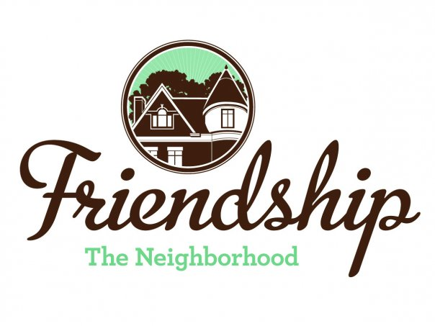 FRIENDSHIP COMMUNITY GROUP

Housing and Business Borders Committee
Monthly Meeting Agenda

Meeting Date/Time: Tuesday, January 7, 2020
6:30 pm
Location: Pittsburgh Glass Center
5472 Penn Avenue
Pittsburgh

Committee Members:  Chair: Vince Manetti  Board Member Representatives: Evan Stein, Tom Youngs  Community Representatives: John Axtell, Jennifer Haven | Attendees:
AGENDA ITEM
Sally Stadelman, Government and Community Affairs, Department of Permits, Licenses, and Inspections

  - How to confirm legal occupancy?
  - How to work most efficiently to bring a concerted effort to hold real estate companies accountable?
  - Discuss concerns with problem landlords
  - What department handles trash issues – PLI or DPW?
  - How to address illegally subdivided buildings
  - Do inspectors respond to speculators hoping to obtain buildings at reduced prices?
Neighborhood Development Updates

- Penn Plaza-Enright Park (Jennifer and John)

- Liberty Ave and Baum retail development

- Key Bank, Penn and Negley

  - Contact name and number?

- Baumhaus Phase II Update

- 5226 Penn Ave

Miscellaneous Updates

- DPW graffiti policy clarification (Tom Y)
- Children’s Home HVAC noises
- City meeting regarding Baum Grove street art project (Jennifer)

Other Items

- To consider – should FCG boundaries be extended to include residents on Baum and Center near Baumhaus?
- To consider – should Friendship be rezoned?

New Items

- 2020 goals and objectives?
- 2020 invited presenters?

Next Meeting

February 4, 2020, Pittsburgh Glass Center

