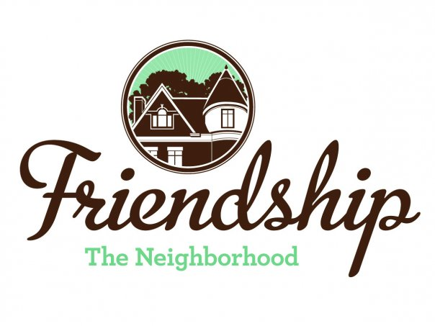 FRIENDSHIP COMMUNITY GROUP

Housing and Business Borders Committee
Monthly Meeting Summary

Meeting Date/Time: Tuesday, December 3, 2019
6:30 pm
Location: Pittsburgh Glass Center
5472 Penn Avenue
Pittsburgh

Committee Members:  Chair: Vince Manetti  Board Member Representatives: Evan Stein, Tom Youngs  Community Representatives: John Axtell, Jennifer Haven | Attendees:  Vince Manetti  Tom Youngs  John Axtell
AGENDA ITEM | SUMMARY
Neighborhood Development Updates  - Penn Plaza-Enright Park (Jennifer and John)  - Liberty Ave and Baum retail development  - Key Bank, Penn and Negley  - Baumhaus Phase II Update – Summary of meeting on 11/21/19, next steps  - 5226 Penn Ave – Summary of Meeting on 11/20/19, letter to owner and next steps | - John reported that all parties are implementing the consent agreement. The housing committee as envisioned in the consent agreement must now be formed and will consist of representatives from FCG, Bloomfield-Garfield Corp., Enright Park Neighborhood Assoc. and the City. The appropriate neighborhood associations must continue their vigilance to confirm that the park is constructed at the same time as the building development and that Eva Street continues to be considered.  - The construction seems to be complete and stores are opening. This item will be removed from future agendas.  - Demolition has not yet begun. John’s research indicates that City building permits were issued on 10/25/19. John also stated that the Key Bank vice president who was the community liaison had left the bank. John said that he would contact the bank’s attorney, Bill Sittig, in order to obtain the name and phone number of a construction liaison for any possible neighborhood concerns.  - Several Committee members and neighborhood residents met with Mike Gornick from Baumhaus. A separate meeting summary will be developed.  - John stated that he and Jennifer will develop a checklist of concerns to share with the owner and architect. John will provide the checklist to the Committee and effected Friendship residents prior to the 12/5/19 Zoning Board of Adjustment meeting.
Miscellaneous Updates  - DPW graffiti policy clarification (Tom Y) | - Tom once again contacted Bill Crean in the City’s Department of Public Works but did not receive a response.
Other Items  - Question about who maintains the Committee email distribution list – update (Tom Y)  - Children’s Home HVAC noises | - Tom determined that FCG Treasurer Larry Laude maintains the Committee email distribution list.  - John and Vince reported that Friendship resident, Mike Dolan, continues to pursue this issue and that City Mayor’s Chief of Staff, Dan Gillman, stated “I’m working on it”.
New Items  - Develop questions for Ms. Stadelman at the 1/7/20 Committee meeting. | - The Committee members brainstormed several items –  - How to confirm legal occupancy?  - How to work most efficiently to bring a concerted effort to hold real estate companies accountable?  - Discuss concerns with problem landlords  - What department handles trash issues – PLI or DPW?  - How to address illegally subdivided buildings  - Do inspectors respond to speculators hoping to obtain buildings at reduced prices?  - John stated that he and Jennifer would brainstorm more ideas  - City meeting regarding Baum Grove street art project. Tom to contact Jennifer to see if she attended meeting.  - To consider – should FCG boundaries be extended to include residents on Baum and Center near Baumhaus?  - To consider – should Friendship be rezoned?  - Several announcements in an email from Christina Howell at Bloomfield Development Corporation –  - Hampton Inn at 4520 Penn Avenue – an article was published in the December 2019 issue of The Bulletin. Additional information and renderings are on the BDC website – bloomfieldnow.org  - Hough Brewing, 4568 Penn - The building is for sale and the owner has not responded to emails. BDC assumes that the owner has abandoned the concept  - Helltown Brewing, 4801 Penn – BDC hasn’t made contact with the owner  - Platform Brewing, 4805 Penn – BDC hasn’t made contact with the owner  - Meeting adjourned at 7:50 pm
Next Meeting

January 7, 2020, Pittsburgh Glass Center

Sally Stadelman, Government and Community Affairs, Department of Permits, Licenses, and Inspections from the City’s Permits, Licensing and Inspection will present

