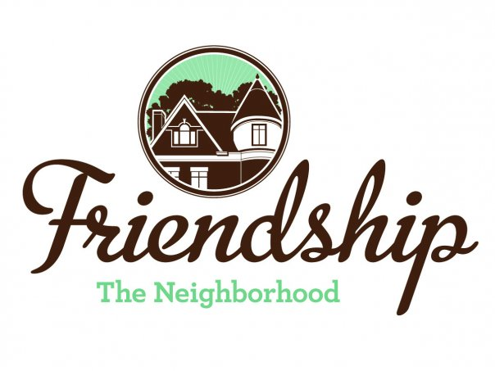 FRIENDSHIP COMMUNITY GROUP

Housing and Business Borders Committee
Summary

Meeting Date/Time: Tuesday, October 6, 2020
6:30 pm

Location: “ZOOM” Video Conference

Committee Members:  Chair: Vince Manetti  Board Member Representatives: Jayne Bower, Sara DeLucia, Tom Hritz, Danielle Novick, Tom Youngs  Community Representatives: John Axtell, Jennifer Haven | Vince Manetti  Tom Youngs  John Axtell, Jennifer Haven  Residents: Barbara Adams, Emily George, Lewis Kwett
AGENDA ITEM | SUMMARY
Neighborhood Development Updates  - Penn Plaza - Enright Park  - Update on construction  - Key Bank, Penn and Negley  - Baumhaus Phase II update  - Graffiti (Brian Sullivan)  - 5226 Penn Ave  - Penn Avenue Phase II  - Howard Hanna Shadyside Office, 5501 Baum Boulevard  - 353 Stratford – Building permits  - 5231 Liberty Ave  - Restaurant Special Exception Hearing 9/3/2020 (Sara) | - Work continues, soil is currently being placed on planned park area, some concern that the Enright Park area may be used throughout construction for staging or “lay down” area  - John will provide a copy of the construction plan for Committee review  - Work seems to be ending with a 10/26/20 opening planned  - There was some discussion regarding Brian Sullivan’s email dated 9/28/20 summarizing his conversation with Mike Gornick at Baumhaus regarding graffiti. Mr. Gornick will apparently attempt to deal with graffiti on his own.  - Vince will send a copy of the recent presentation regarding renovations and development at the Howard Hanna property at 5501 Baum Blvd to Mr. Gornick  - There will be a community meeting through Zoom at 5:00 pm on 10/7/20 to discuss upcoming renovations and development  - No update  - FCG, as a registered community organization, to host an upcoming Development Activities Meeting. Rick Swartz from Bloomfield- Garfield Corporation (BGC) to be a panel member.  - There will be the necessity for community notification of the DAM  - Currently, FCG and the community do not have a response to the proposed renovations  - There was discussion of a joint FCG, BGC, and Bloomfield Development Corporation letter regarding the renovations  - John Axtell stated that would contact resident, Tom Mangan, for his thoughts about the development  - There are approximately 20- 22 near neighbors  - It appears that construction has stopped for several weeks.  - Jennifer Haven stated that there does not seem to be a building permit issued for the work as of 10/1/20  - Vince will contact City Department of Permits, Licenses and Inspections (PLI) director, Sarah Kinter, for latest information  - No update on the special exception hearing. John stated that he would share the YouTube video from the hearing.  - Some neighbors are complaining of odors from the location
Neighborhood Environment Updates  - Baum-Center Initiative (BCI) participation  - Regular update  - Residential Permit Parking (Tom)  - “Rightsizing” the trash cans at various buildings  - DPW graffiti policy clarification (Tom)  - Update to FCG website  - Children’s Home HVAC noises  - Baum Grove street art project grant – Bloomberg Philanthropic Arts Initiative (Jennifer)  - Coral Street Neighborway  - Hertz location, 5634 Baum Boulevard.  - Reuse of space as a result of the Hertz bankruptcy.  - Letter to Hertz regarding parking in neighborhood (Tom) | - Barbara Adams reported that BCI is attempting to contact local building owner, John Odell, regarding the building at 5640 Baum Boulevard which was condemned on 9/25/19  - There was some discussion regarding Tom Youngs’ email exchange with Elaina Zaitsoff of the Coalition of Oakland Residents dated 9/7/20. No action has yet occurred regarding changes to the RPP  - No updates  - There was additional discussion regarding how to address problem landlords as well as building code violations  - How to get City to strictly enforce  - Work with PLI or  - City Department of Public Works  - There was discussion of a particularly problematic property at 310 Roup  - Tom Y. has shared a draft will Bill Crean and Alicia Carberry from the Mayor’s Office and will soon share with the Committee.  - Resident Mike Dolan is connecting with Sarah Kinter from PLI to discuss further  - City information suggests that an enforcement action is occurring soon in regard to building a structure to reduce the noise  - There may also be a City action regarding broken sidewalks  - Jennifer and Sara DeLucia continue to work on this effort outside of the Committee as part of a larger FCG effort with a recent ideation session and monthly Bloomberg phone calls  - Committee agreed to remove from the monthly agenda  - Committee agreed that BDC is adequately addressing  - Tom Y. recently sent a letter to Hertz location and has not received a response
2020 Goals Updates  - Update HBBC mission statement, vision and website (tabled from September meeting)  - Meeting presenters have changed based upon COVID-19 stay-at-home orders. Presentations below are tentative –  - Pittsburgh Glass Center (regarding nearby proposed renovations) (11/3/20?)  - Environmental Services Enforcement (FCG Quarterly Community Meeting?)  - Graffiti (FCG Quarterly Community Meeting?) | - No updates
Long Term Goals
- HBBC recommendation that FCG should consider applying for a grant to develop a new strategic plan / community plan
  - Incorporate consideration of expansion of RCO boundaries
  - Incorporate possible development of “Penn Avenue overlay”
  - Include possibility of neighborhood zoning changes?

Not Actively Tracked Projects

- 5222 Penn Ave renovations
- North Negley Residences – B’nai Israel
- Montana Building on Penn Avenue – renovations
- Two Frays Brewing on Penn Avenue - development
- Aldi renovations (Baum Blvd)
- Shur-Sav (Bloomfield)
- West Penn Hospital Institutional Master Plan
- Continuation of discussion of “house flippers” in Friendship
  - John and Jennifer developing a presentation regarding actions homeowners may consider when approached by house flippers.
- New tax abatement programs
  - Jennifer - November

New  - Next meeting date (Election Day) | - Committee agreed that the November meeting would be delayed to the second Tuesday of the month so as not to conflict with Election Day
Next Meeting  November 3, 2020, Location - Zoom | Next Meeting - Change  November 10, 2020, Location - Zoom

