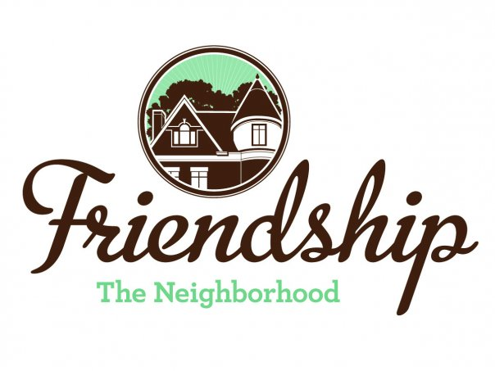 FRIENDSHIP COMMUNITY GROUP

Housing and Business Borders Committee
Agenda

Meeting Date/Time: Tuesday, September 1, 2020
6:30 pm

Location: “ZOOM” Video Conference

Committee Members:

Chair: Vince Manetti

Board Member Representatives: Jayne Bower, Sara DeLucia, Tom Hritz, Danielle Novick, Tom Youngs

Community Representatives: John Axtell, Jennifer Haven
AGENDA ITEM | SUMMARY
Sarah Kinter, Director
City of Pittsburgh, Department of Permits, Licenses and Inspections (PLI)

Neighborhood Development Updates

- Penn Plaza - Enright Park
  - Update on construction

- Key Bank, Penn and Negley

- Baumhaus Phase II update
  - Graffiti (Brian Sullivan)

- 5226 Penn Ave
  - Update regarding discussion with owner (Jennifer)

- Shur-Sav (Bloomfield)

- Penn Avenue Phase II

- Howard Hanna Shadyside Office, 5501 Baum Boulevard

- 353 Stratford – Building permits

- 5231 Liberty Ave
  - Restaurant Special Exception Hearing 9/3/2020

Neighborhood Environment Updates

- Baum-Center Initiative (BCI) participation
  - Regular update

- Residential Permit Parking (Tom)

- “Rightsizing” the trash cans at various buildings

- DPW graffiti policy clarification (Tom)
  - Update to FCG website

- Children’s Home HVAC noises

- Baum Grove street art project grant – Bloomberg Philanthropic Arts Initiative (Jennifer)

- New tax abatement programs
  - Jennifer - November

- Continuation of discussion of “house flippers” in Friendship
  - John and Jennifer developing a presentation regarding actions homeowners may consider when approached by house flippers.

- Coral Street Neighborway
  - Resolution for FCG Board support of BDC letter passed at August 12, 2020 FCG Board meeting
  - Need to convey to BDC

- Hertz location, 5634 Baum Boulevard.
  - Reuse of space as a result of the Hertz bankruptcy.
  - Letter to Hertz regarding parking in neighborhood (Tom)

- West Penn Hospital Institutional Master Plan (Planning Commission meeting on July 28, 2020)
2020 Goals Updates

- Update HBBC mission statement, vision and website.

- Meeting presenters have changed based upon COVID-19 stay-at-home orders. Presentations below are tentative –

  - Pittsburgh Glass Center (regarding nearby proposed renovations) (11/3/20?)
  - Environmental Services Enforcement (FCG Quarterly Community Meeting?)
  - Graffiti (FCG Quarterly Community Meeting?)

Long Term Goals
- HBBC recommendation that FCG should consider applying for a grant to develop a new strategic plan / community plan
  - Incorporate consideration of expansion of RCO boundaries
  - Incorporate possible development of “Penn Avenue overlay”
  - Include possibility of neighborhood zoning changes?

Not Actively Tracked Projects

- 5222 Penn Ave renovations
- North Negley Residences – B’nai Israel
- Montana Building on Penn Avenue – renovations
- Two Frays Brewing on Penn Avenue - development
- Aldi renovations (Baum Blvd)

New

Next Meeting

October 7, 2020, Location TBD

