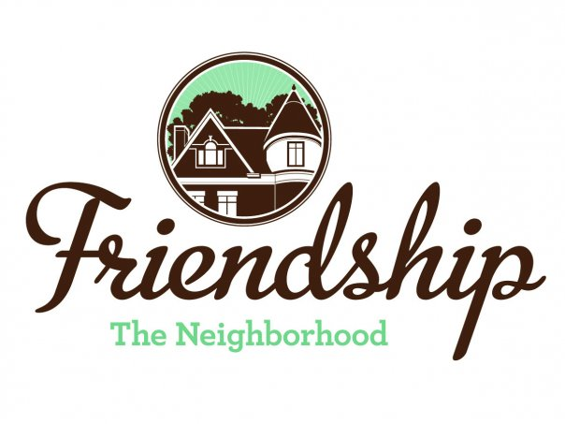 FRIENDSHIP COMMUNITY GROUP

Housing and Business Borders Committee
Summary

Meeting Date/Time: Tuesday, June 2, 2020
6:30 pm

Location: “ZOOM” Video Conference

Committee Members:  Chair: Vince Manetti  Board Member Representatives: Jayne Bower, Sara DeLucia, Tom Hritz, Danielle Novick, Tom Youngs  Community Representatives: John Axtell, Jennifer Haven | Attendees:  Vince Manetti  Tom Hritz, Tom Youngs  John Axtell, Jennifer Haven  Others in attendance – Barbara Adams
AGENDA ITEM
Neighborhood Development Updates  - Penn Plaza - Enright Park  - Update on construction  - Update on attorney’s invoices  - Liberty Ave and So. Atlantic / Baum retail development  - Key Bank, Penn and Negley  - Baumhaus Phase II update  - 5226 Penn Ave  - Update from Rick Swartz at Bloomfield-Garfield Corporation regarding neighborhood letter  - Shur-Sav (Bloomfield)  - Board resolution  - U-haul signage  - City Zoning Board of Adjustment rejected variance  - Any updates? Will owners appeal?  - Penn Avenue Phase II  - Status of draft letter from FCG  - Need to submit it to the Board?  - Additional information - https://apps.pittsburghpa.gov/redtail/images/8591_Penn_Ave_Phase_II_Presentation_02_06_20.pdf | Vince began the meeting 6:42 pm  - Construction has resumed  - Interested parties are awaiting an update on the park renovations schedule. The expansion of the TRID from one-half mile to three-quarters of a mile is pending before City Council. John will share through email with the Committee members the letter that HBBC recently submitted to the Mayor in regards to TRID expansion legislation in Council. The Penn Plaza Housing Committee will not convene until the TRID is expanded.  - No update on attorney’s invoices.  - Committee members decided to remove from future agendas and address as retail locations require zoning exceptions.  - Construction continues.  - Zoning variances have been approved. Development will soon be presented to the City Planning Commission.  - Developer is switching contractors  - No update from Rick Swartz. Jennifer agreed to contact the owner for an update.  - Jennifer will provide to Bloomfield Development Corporation (BDC) the resolution passed by the FCG Board of Directors at its May 13, 2020 meeting.  - There have not been any updates filed. Committee members decided to remove from future agendas.  - BDC recently submitted a very thorough letter and presentation to the City regarding this item. Jennifer or John will send a link to the letter and presentation.  - Committee members agreed to continue with a letter from FCG to the City regarding this item and ask the FCG president to sign.  - Committee members also agreed to support the BDC letter and presentation. Committee submits the following resolution to the FCG Board of Directors for its consideration and action –  Resolved:  FCG 1) supports the Bloomfield Development Corporation’s and Bloomfield Livable Streets’ letter dated May 19, 2020 to the City of Pittsburgh Department of Mobility and Infrastructure Director regarding Phase II Penn Avenue Reconstruction as can be found at -https://bloomfieldlivablestreets.org/our-campaigns/penn-avenue-reconstruction-phase-ii/ and 2) requests that BDC keep FCG updated regarding responses to the letter.
Neighborhood Environment Updates  - Baum-Center Initiative (BCI) participation  - Regular update  - Residential Permit Parking  - Board resolution  - “Rightsizing” the trash cans at various buildings  - Inviting Donald Matthews from the City to a future HBBC meeting (Brian Sullivan and Vince)  - DPW graffiti policy clarification (Tom)  - Children’s Home HVAC noises  - Aldi renovations? (Vince)  - Owner’s other development efforts?  - Baum Grove street art project grant – Bloomberg Philanthropic Arts Initiative (Jennifer)  - New tax abatement programs  - Jennifer - July  - Continuation of discussion of “house flippers” in Friendship | - The May 2020 meeting was cancelled. The June 16, 2020 meeting is still being considered. FCG representative to BCI, Barbara Adams, discussed several ongoing City projects and the City’s 2021 capital budget survey of which responses are due by June 19, 2020.  - Tom conveyed the May 13, 2020 FCG Board resolution to the Coalition of Oakland Residents.  - John will send information to Brian Sullivan regarding accessing the property database.  - Tom will develop language regarding the process to address graffiti in the neighborhood to post on the FCG website.  - Neighbors, led by Mike Dolan and Kristin Hughes, contacted the City again without any action occurring. Jennifer will connect with Mike and offer to write an additional letter with HBBC’s support to the City.  - Committee members noted this long term problem and would like FCG approval to continue to pursue this issue with the City. Committee submits the following resolution to the FCG Board of Directors for its consideration and action –  Resolved:  The FCG Board of Directors grants the Housing and Business Borders Committee continuing authority to pursue resolution of noise issues at the Children’s Home primarily through interaction with the City.  - No significant updates  - No updates.  - Presentation may be moved to September  - Jennifer to work with Sara DeLucia regarding information about mortgage payments on FCG website and Facebook page. John and Jennifer will develop a presentation regarding actions homeowners may consider when approached by house flippers.
2020 Goals Updates  - Update HBBC mission statement, vision and website  - Meeting presenters have changed based upon COVID-19 stay-at-home orders. Presentations below are tentative –  - Environmental Services Enforcement (FCG Quarterly Community Meeting?)  - Permits, Licenses and Inspections (9/1/20?)  - Pittsburgh Glass Center (regarding nearby proposed renovations) (11/3/20?)  - 311 (7/7/20?)  - Graffiti (FCG Quarterly Community Meeting?) | - Tom to circulate FCG mission statement as adopted at May 12, 2020 FCG Board of Directors meeting.  - -  - FCG Quarterly Community Meetings are still under discussion  - Tom to contact PLI for presentation  - PGC – under review  - Wendy Urbanic from the City’s 311 department to present on 7/7/20
Long Term Goals  - HBBC recommendation that FCG should consider applying for a grant to develop a new strategic plan / community plan  - Incorporate consideration of expansion of RCO boundaries  - Incorporate possible development of “Penn Avenue overlay”  - Include possibility of neighborhood zoning changes? | - FCG Board of Directors is considering. No further updates.
Not Actively Tracked Projects  - 5222 Penn Ave renovations update  - North Negley Residences – B’nai Israel  - Montana Building on Penn Avenue – renovations  - Two Frays Brewing on Penn Avenue - development  - Changes at West Penn Hospital | - No updates.
New | - Coral Street Neighborway - John to send link to BDC letter to Committee for further review.  - Hertz location at three-way intersection of Baum, Negley and Roup. Consideration of contacting owners regarding reuse of space as a result of the Hertz bankruptcy. Committee will discuss over email.
Next Meeting  July 7, 2020, Location TBD | - Vince to contact the PGC regarding using the meeting room in July.

